VFPX Project Overview/Proposal

Instructions: Fill out each of the following sections. Then include any supporting files for the proposed project with this document in a zip file and email it to [projects@vfpx.com](mailto:projects@vfpx.com).

Please note that commercial products, demo versions, or any project that does not include complete source code does not fall within the scope of VFPX and licensing will not be accepted.

What is the proposed title for this project?

Dynamic Forms

What problem does this project address?

Eliminates the manual layout and placement of UI controls in the FoxPro Form Designer. Allows for dynamically rendering a display/edit form based on properties that exist on a target object.

What are the goals of this project?

To provide a programmatic/declarative syntax for defining a user input form at run time.

What programming languages or technologies will be used for/by this project?

100% VFP, with a syntax influenced by HTML/XAML layout.

Are there existing code, examples, or documents included with this project proposal? If so, please give a brief description of the files being included.

DynamicForm.prg working sample included.

Are there any existing licenses, copyrights, or trademarks that this project would be subject to? If so, please explain.

No.

Do you have any people interested in being the project manager or participating as developers on this project at this time? What type of resources are you initially anticipating?

I will be the project leader. In addition to myself, I have one tester who has already used this tool in a production app. I am hopeful that the project will attract a few other early-adopters to influence the development tool during the beta cycle.

Who should members of VFPX contact if interested in working on this project?

Matt Slay

mattslay@jordanmachine.com

Is there an ongoing discussion out on the VFPX Message Boards regarding this project? If so, please provide the location of the thread.

Not yet.

Is there any additional information that you feel is pertinent to this project?

Screenshot… Dynamic Form sample rendered from markup code:

(See next page…)

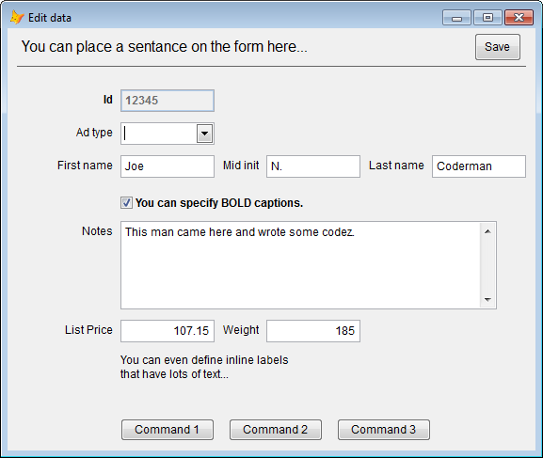

Markup syntax sample:

